

Hash Your First Block – Blockchain Basics and Setup.



**Objective/Aim:**

To understand hashing in blockchain and simulate creating the first block linked with a hash.

**Apparatus/Software Used:**

* Laptop
* Blockchain Demo website → https://andersbrownworth.com/blockchain/hash
* Browser

**Theory/Concept:**

**What is blockchain?**

Blockchain is a shared, immutable digital ledger, enabling the recording of transactions and the tracking of assets within a business network and providing a single source of truth.

Within a blockchain network the data is stored in the in the all the different node or computers which make it difficult to taper the data store in it, ones the data store in blockchain I cannot be erased, to make any change in the blockchain one should have the 51% majority permission.

* Hashing: Converts input data into a fixed-length cryptographic string (SHA-256).
* Block: Contains data, current hash, and previous hash.
* Linking Blocks: Each block refers to the hash of the previous block → ensures immutability.
* Avalanche Effect: Small change in input causes a completely different hash.



**Procedure:**

|  |  |  |  |
| --- | --- | --- | --- |
|  |  |  |  |
|  |  |  |  |
|  |  |  |  |
|  |  |  |  |
|  |  |  |  |
|  |  |  |  |
|  |  |  |  |

* Open the Blockchain Demo website.
* Enter data into the block and note the generated hash.
* Modify the data and observe how the hash changes.
* Add a second block → observe it links with the previous block’s hash.
* Change data in the first block → notice that the chain breaks.

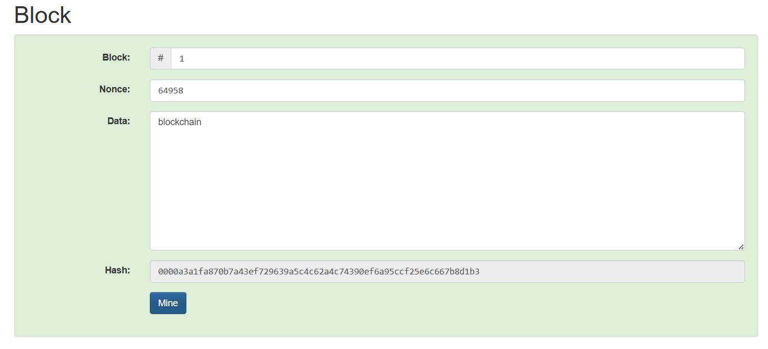

**Observation Table:**



* Entering data in the block generated a unique hash.
* Changing even a single character in the data produced a completely different hash.
* The hash length remained fixed at 64 characters (SHA-256 output).
* Hash uniquely represented the block’s data, ensuring integrity.

